THE Mow-hawk


To style your lawn MowAliciously




Customer Care:
+49 178 83027493

Customer Care:
+49 176346 738
Aadithya Ramamurthy & Vedhashruthi Harinath
User Manual

Contents

- Safety Instructions...................................................................................................... 3
- Getting to know your Bot…......................................................................................... 5
- Installing Mower, Yourself?........................................................................................ 6
- Mechanical Parts …..................................................................................................... 8
- Connecting to Internet................................................................................................ 9
- Mode of Operation………………………………………………………………………………………………… 10
- Scheduling................................................................................................................... 11
- On Board HMI.............................................................................................................. 12
- Charging Station.......................................................................................................... 13
- Maintenance………………………….................................................................................... 14
- Troubleshooting……………………..………………………………………………………………………………. 15
- Technical Specifications…………………………………………………………………………………………… 16

- Safety Instructions

⚠ Read all safety warnings and all instructions for the safe operation of the machine.

- The Mow-Hawk is not designed to be used by physically challenged people in any case.
- Keep away from children.
- The operator or user is responsible for accidents or hazards occurring to other people or their property.

Before Getting Started

- Ensure the correct installation of boundary as instructed.
- A clean and minimum obstructions are expected in the moving area before starting itself.
Turn off the Mower, remove the battery, wear protectives gloves, and take care when inspecting.
- Do not put hands or feet near rotating parts and electronic parts like wheels, wires.
- Never pick up or carry Mower while it is running.
- Turn off the machine and remove the battery before clearing a blockage and before checking cleaning or working on Mower.
- It is not permitted to modify the original design of Mower.
- All modifications are made at your own risk.
- Start the mower according to the instructions.
- When the power key is switched on, make sure you keep your hands and feet away from the rotating blades.
- Never lift the mower or carry it when the power is switched on.
- Neither should it be used with defective, screws, nuts or cables.
- Switch off Mower when you do not intend to use it for a long period of time.
- Mower can only start when the power is switched on and the correct login details have been entered.
- Avoid using Mower in bad weather conditions especially when there is a risk of lightning.
- Do not touch moving hazardous parts before these have come to a complete stop.
- Do not leave Mower to operate unattended if you know that there are pets, children, or people in the vicinity.
- Do not wash the Mower.
- Keep all nuts, bolts, and screws tight to be sure that it is in the safe working condition.
- Inspect Mower each week and replace worn or damaged parts for safety.
- The mower is supposed to work only on flat and smooth surfaces.
- Start the mower as per the instructions. If not, the damages caused cannot be covered by warranty.
- Do not use the robotic lawnmower if the main switch does not work.
- Lawn Mower can never be used when the sprinkler is present since the robot cannot detect wet conditions.

⚠ Environmental Protection
Waste electrical products should not be disposed of with household waste. Please recycle where facilities exist. Check with your Local Authority or retailer for recycling advice.

- Getting to know your BOT?
In the following section, we would like to help you better understand how the Mow-Hawk works.
- It can be an autonomous or a manual bot, where the user can choose its mode of operation on its web-interface.
- On the autonomous mode, it can go in a defined path on its own, knows to stop, draw back, and turn around when it detects into something blocking its path, also when it needs to go to its charging base.
- On the manual mode, we can operate its navigation throughout the lawn using a few buttons on the web-interface.
- When your Mower needs to recharge, it will stop mowing and follow the boundary back to its charging base. Once charging is complete, Mower will automatically resume mowing or stay in the charging base according to its mowing schedule.
- Mower is programmed to mow the grass along the perimeter of your lawn according to the schedule set by the owner. If you want to change the dates and times, you can modify it via your smartphone or by using the ‘See detailed’ instructions in this manual.

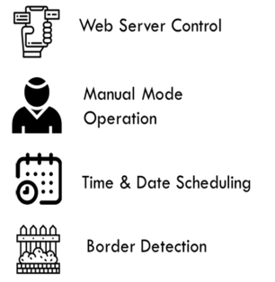
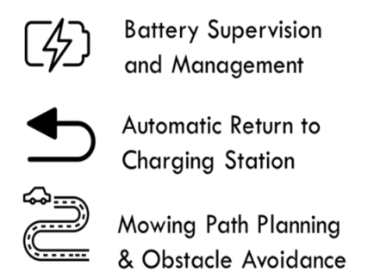

- Installing the Mower, yourself?

Mower’s boundary tape is designed to stay on the surface of your lawn Mower over the perimeter. This allows you to easily check everything and, if necessary, change the layout before burying the wire.
The charging station is where your Mower goes to have its battery recharged. It is also the parking lot where it rests in between one mowing session and the next.
Locate a proper position for it, bearing in mind:
- It needs to be powered, so it should be no more than 10m away from an AC mains outlet.
- If possible, choose a shaded position as batteries and chargers do not like over-heating. The base needs to sit on flat land to ensure effective docking.
- Avoid places close to irrigation sprinklers.
You can place the charging station on your lawn or on a hard surface like a walkway, provided that the lawn and the hard surface are at the same height (no steps).
Charging station checklist:
• within reach of AC mains
• in shade
• straight path on entrance; straight path on exit if necessary
• flat land
• no irrigation sprinklers nearby

The tape must be placed at a certain distance from the edge of the lawn. This distance changes depending on what is on the other side of the edge.
Identify forbidden areas: You do not want your robot mower to behead flowers, dive into a water feature, or shred tree roots that emerge from the ground. Locate these areas and surround them with boundary wire to prevent Mower from accessing them.
The boundary wire is a single loop connected on both ends to the charging station, so you will have to depart with the wire from the border, surround the area you want to protect, then take the wire back to the border.
If areas to be surrounded are far away from the border of your lawn, or if you have several areas and tree roofs to protect, this traditional method is time consuming.

- Mechanical Parts
Main Components:
- Robot Chassis
- Wheels and Mechanical Joints
- DC Motors and Motor Drivers
- Arduino UNO
- Sensor Shield
- Node MCU
- Battery
- IR Sensors
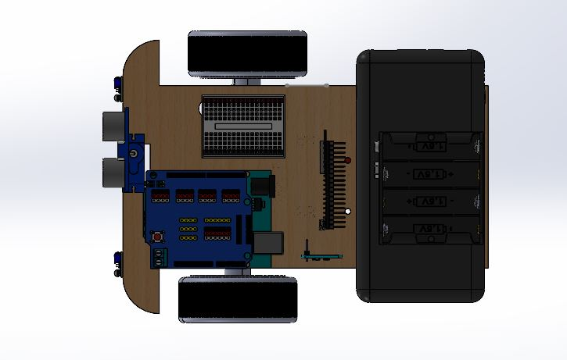
- INA219 Sensors
Top View

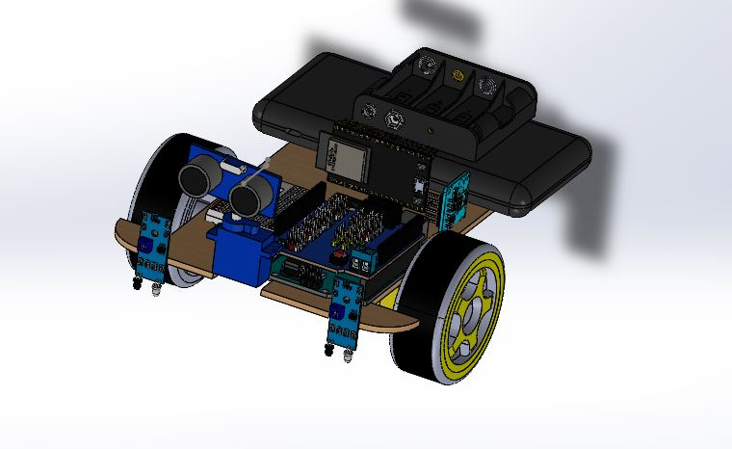

Isometric View

- Connecting to Internet

Follow the following steps to configure and control the Mower from your Mobile Phone Website.
- Turn on your Wi-Fi and connect to the Wi-Fi named “ssid”.
- Enter Addresses 192.168.4.1 in your browser.
- A login page will be seen. Enter the login details provided in the manual.
- Username: Mowhawk
Password: pwd123
- You can change the username, password according to your choice.
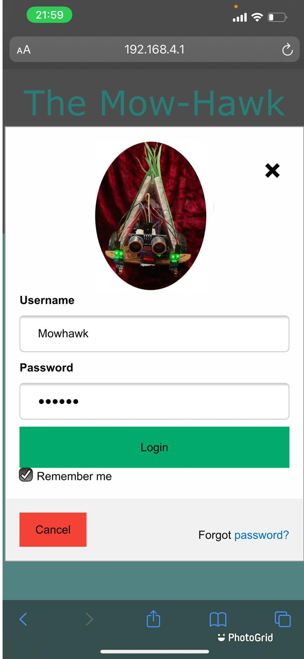
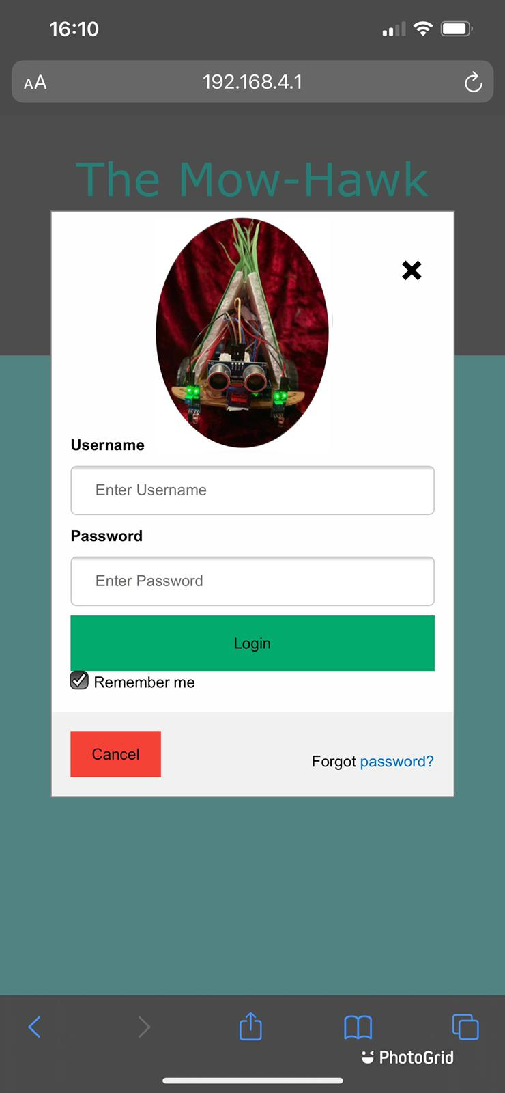
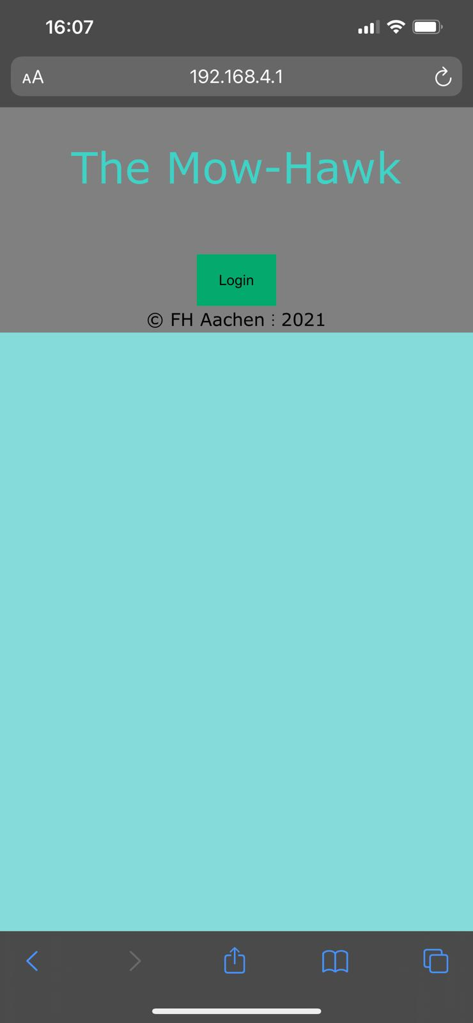
- When you login with your passwords, a new page will be seen.
Login Page

- Mode of Operation
Once you enter the main page after the login, you will be in the manual mode of operation by default. You could either control the Bot on the manual mode or you could click on “Auto” mode for it mow on its own on the scheduled time.
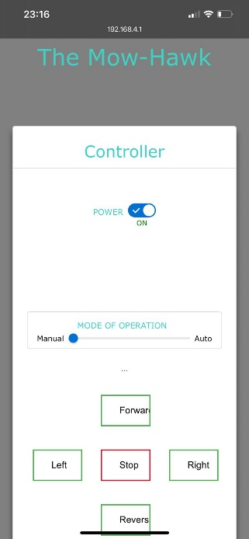
Manual mode
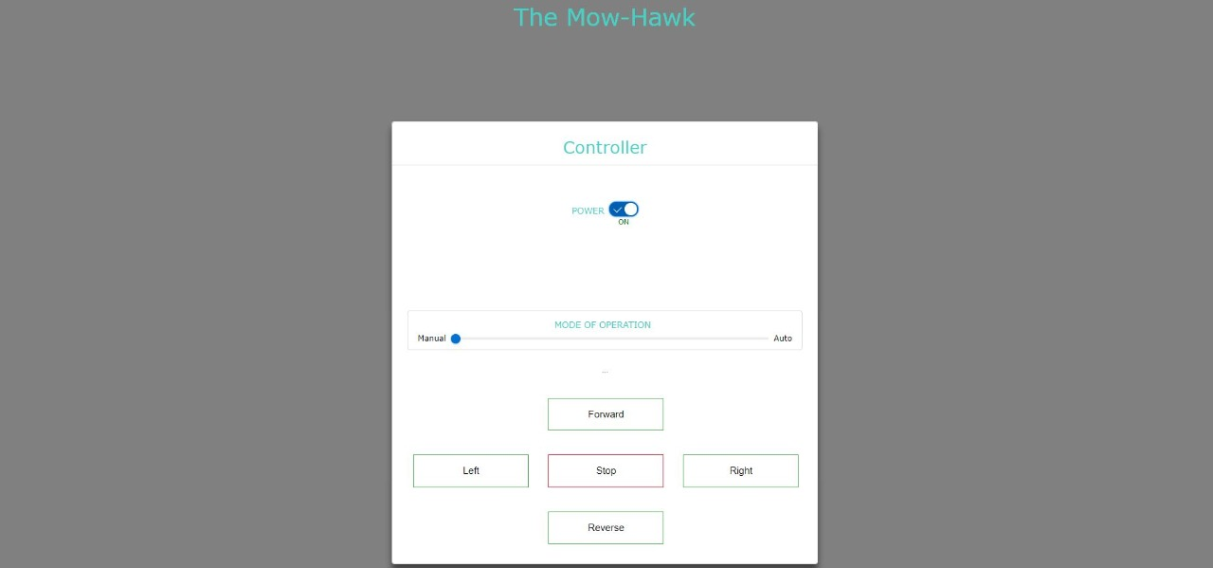
On Browser
Autonomous Mode
On Phone
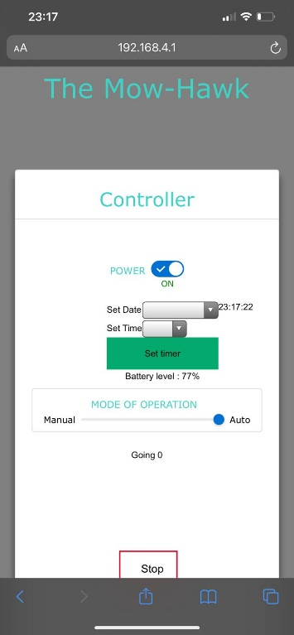
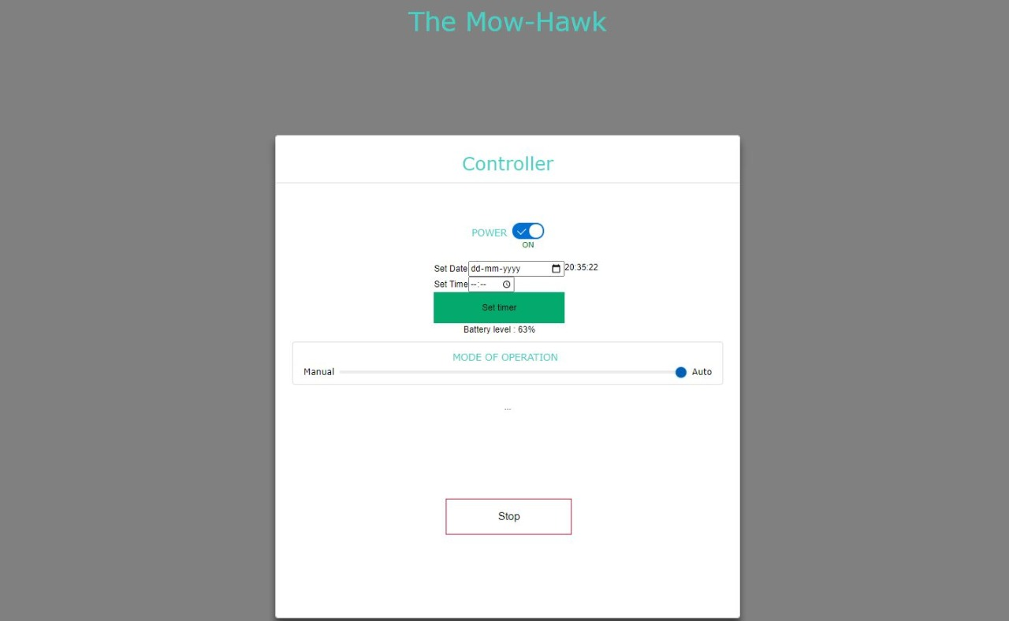

On Phone
On Browser
- Scheduling

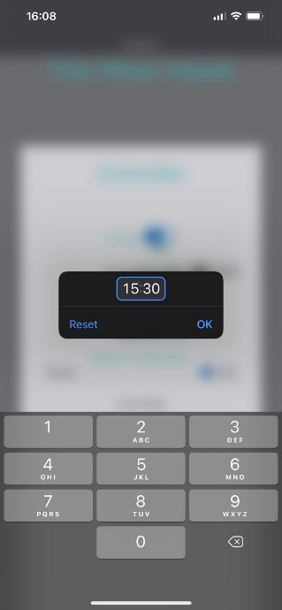
On the autonomous mode of operation. It gives the option of scheduling the Mowing dates and time for the Preplanned Mowing. You can click on the “Set timer” after scheduling the desired date and time for it to start at that time. Stop button will also be handy for the Mowing.
Time
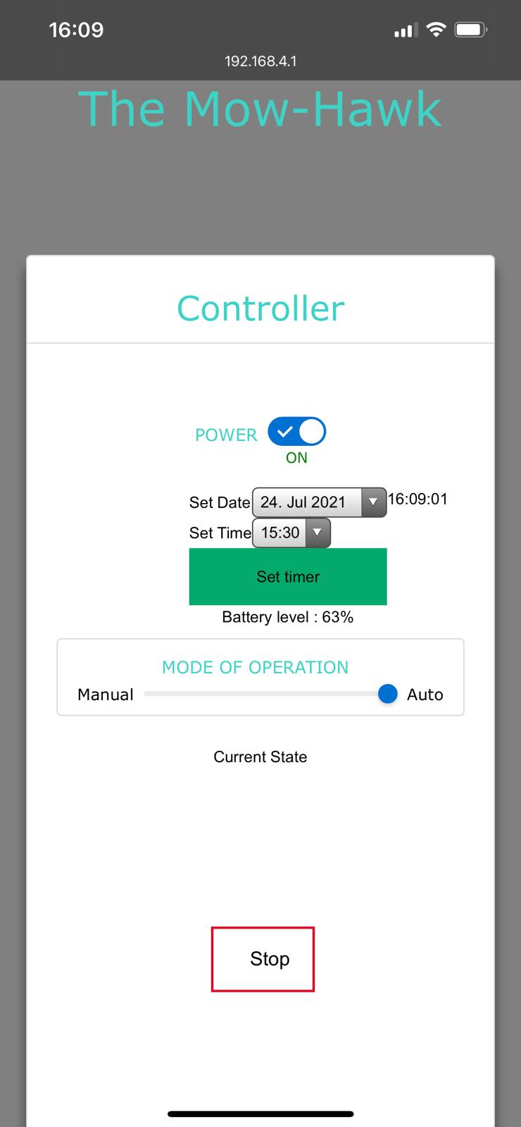
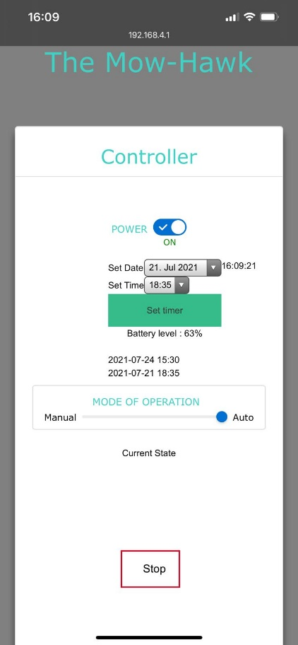
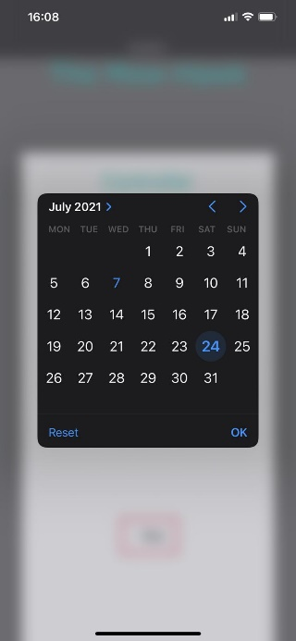
Date

Scheduling

- On Board HMI

LCD 16*2 Display showing the ongoing process and any emergency message.
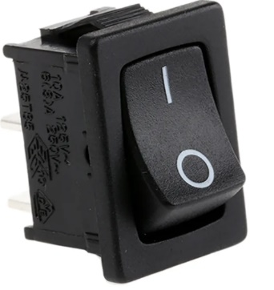
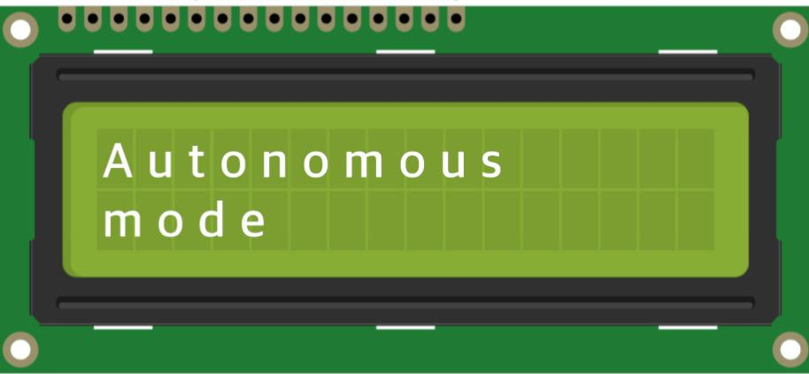
Emergency Stop Button used to cut Power in case of any Emergency.

- Charging Station

Following are the cases designed for the Mower to go back to the charging station:
- Mowing Path completed
- Low Battery
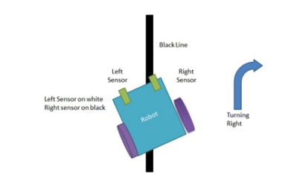
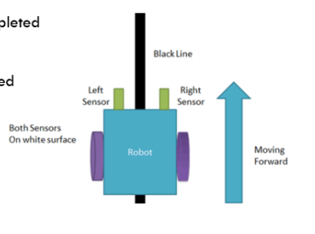

Line Following

- Maintenance
Your mower works hard and needs to be cleaned and checked from time to time. Weekly maintenance should be done to make to bot work perfectly. This section of our guide helps you keep the mower in a good shape so it can last for years without troubles. Here is how to take care of your Mower:
- KEEP IT CLEAN
- Your Mower should be cleaned regularly. Do not forget to turn off Mower before cleaning it. For extra safety, remove the battery.
- The wheels and electric connections should be intact for proper mowing.
- WARNING! DO NOT pour running water on your Mower. Water can go inside the sealings and damage electronic and mechanical parts.
- Cleaning the upper body
• Use a brush or a clean cloth to remove built-up dirt
- Cleaning the Bottom
• Flip Mower upside down
• Remove any dirt using a brush to remove
• • Clean the blade disc, the chassis, and the front wheel(s) thoroughly with a soft brush.

- KEEP IT CHARGED
  - For the proper storage of the battery, make sure it is fully charged and kept in a cool dry place between - 20°C~60°C.
  - The recommended Mower operation temperature is between 0-55°C.
  - The lifespan of Mower’s battery depends on hours of usage and the length of use per day during the mowing session.
BATTERY and SENSORS
- Mower can be charged manually.
- Connect the charging base to a suitable power supply.
- Manually dock Mower into the charging base while Mower is powered off.
- When the battery is fully charge, turn off the charging. .
- Charge the power-bank every once a day.
- External battery is used for easy replacement in case it is necessary.
- Keep a check on the sensors if they are working up to the mark.
- Wires should be intact.

- Troubleshooting

Symptom | Cause | Solution
Mower is not operating at the correct time. | The clock is not set to the correct time. Programmed cutting times for Mower are not correct. | Set the clock to the correct time. Change the time settings for the mower to start and stop.
Mower wheels skid or repeatedly slip. | Foreign obstacles, such as twigs and branches may be lodged under Mower. The lawn is too wet. | Remove foreign objects from underside of Mower. Wait until lawn has dried.
Mower operative system crashes when charging or on standby. | Software or display fault. | Restart Mower.
Mower flips over. | There is an inclined obstacle on the lawn. | Exclude the obstacle from Mower’s working area.
Mower fails to connect to the internet. | Problem with Wi-Fi, Nodemcu, or the website | Check the connections and internet connections, wiring of Wi-Fi, etc.
Motors running at different speeds | Hardware Problems | Contact Customer Care
Mower is starting to have shorter run-times between charges. | The battery may be exhausted or old. | Replace battery.

- Technical Specification

Specifications
Physical Dimensions | 160 mm x 250 mm x 160 mm
Weight without Battery | 718 g
Battery | 7500 mAh
Output | Max – 10 W

That’s all folks.
Have fun styling your garden mowaliciously!

